Erasmus Work Placement Offer
In Erasmus office of Istanbul Bilgi University 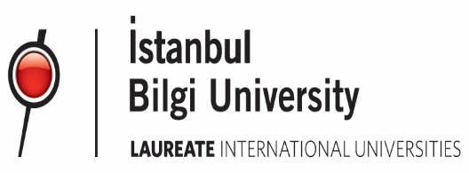
The Work Placement Program is a great way to impress employers and provides you excellent working experience in an office environment. Besides the professional skills that you will gain during this experience, you will also benefit from advantages such as an Erasmus mobility grant provided by your home institution, a meal card, free shuttle services to Bilgi campuses provided by BILGI, and, last but not least, ECTS credits which can be transferred to your home university. Erasmus interns will not generate any financial reimbursements for the department. The intern may receive an Erasmus mobility grant to partly cover the costs of travel and accommodation. Erasmus mobility grants are managed by the intern’s home university. Please find below the description of duties and responsibilities for your future internship. If you are interested in the Erasmus Work Placement program, please send your CV and your possible internship dates to: incoming-intern@bilgi.edu.tr
EMPLOYER INFORMATION
Name of organization | Istanbul Bilgi University / Global Talent Management Center - Erasmus Office
Address | Erasmus Ofis, Eski Silahtarağa Elektrik Santrali, Kazim Karabekir Cad. No: 2/13, 34060 Eyüp - İstanbul TURKEY
Contact Person | Gozde Topraktepe  Email: incoming-intern@bilgi.edu.tr Tel: + 90 212 311 7195 Website: www.bilgi.edu.tr/en
Duration | The placement period will last at least 4 months, but interns who are available for a longer  period will be preferred
Requirements | English - Advanced  Turkish - Intermediate (not mandatory, but preferred)
Working Hours | Monday-Friday, 09:00-17:00
Job description | Helping with the application and admission procedures of international and BILGI students. Preparing data and updating excel tables. Maintaining the office environment through inventory and other administrative tasks. Assisting the operation of events of exchange and international programs. Supporting outgoing and incoming students during application periods and on exchange preparations. Assisting in marketing in study abroad programs by using and developing new approaches to attract more students both outgoings and incomings, and updating the databases.
Free shuttle services | santralistanbul <> Beşiktaş  santralistanbul <> Kuştepe-Trump Towers  santralistanbul <> Dolapdere  santralistanbul <> Halıcıoğlu  santralistanbul <> santralistanbul Annex  santralistanbul <> Pangaltı (Next to Ramada Hotel - In front of Finansbank)  For the shuttle hours follow https://www.bilgi.edu.tr/en/life-at-bilgi/transportation/shuttle/

Erasmus Office - Istanbul Bilgi University

